  - Statistical Quality Control
- Statistical Quality Control (SQC)
Quality has always been an integral part of all products including services. It is an important consumer decision criterion in selecting among competitive products. So, quality improvement has become the key factor for the success and growth of any business organization. Investment on quality improvement gives rich returns. Japan is the best example.
- Quality:
- It is defined as fitness for use. Every product possesses a number of elements that jointly describe its fitness for use. These elements or parameters of quality are called
- quality characteristics.
Quality characteristics may be measurable like length, weight, voltage, etc. or countable like the number of leakage points on a roll of insulated wire. Measurable quality characteristics are referred to as Variables. Often, the quality can not be measured. The units are just classified as defectives or good ones. E.G. a bolt that fits a nut is good and that does not fit is defective. Such quality characteristics are called attributes. Sometimes, although the characteristic may be measurable, but it may be treated as attribute for the sake of simplicity and economy.
Defect and defective:
Quality characteristics are evaluated relative to specifications. Specifications are the desired measurements of the quality characteristics which are set by the management according to the design of the product. Specifications are also referred to as the target or nominal values. A product that fails to meet any specification is said to be nonconforming. A particular instance of nonconformity is called a defect. A product is defective if it has one or more defects which are serious enough to restrict its effective use.
- Statistical Quality Control (SQC)
By SQC we mean the various statistical methods used for maintenance of quality in a continuous flow of products. It involves two types of controls:
1. Process control: Its aim is to quickly detect the occurrence of assignable (identifiable) causes of quality variation in the production process so that corrective action may be undertaken before many nonconforming (defective) units are produced. Process control is achieved through the technique of control charts.
2. Product control: Its aim is to ensure that lots of manufactured products do not contain large proportion of defective items. Product control is achieved through the technique of acceptance sampling inspection plans.
- Process Control In any production process, howsoever well designed and well maintained, it is impossible to produce all items exactly of the same quality. Variation is inevitable. Certain small variation is natural to then process. This natural variation, sometimes called background noise, is the cumulative effect of a large number of small and generally unidentifiable and unavoidable causes called the chance(or random) causes of variation. These are also referred to as common or chronic causes by some authors. Variation due to chance causes can not be prevented and is called allowable variation. A process operating only in the presence of chance causes of variation is said to be stable process and under statistical control. Sometimes, super imposed on the natural variation, will be the variation which occurs when there is something wrong with the process. Causes of such variation are identifiable and generally controllable. These causes of variation are called assignable (or systematic or special or sporadic) causes. Variation caused by assignable causes is called preventable variation. A process operating in the presence of assignable causes
of variation is said to be out of control. Identifying and weeding out the assignable causes of variation from the production process is the aim of process control and is achieved through the technique of control
charts initially developed by W.A.Shewhart of Bell Telephone Lab., USA in 1924.
- Statistical Basis of Control Charts
Rational subgroups: The central idea in Shewhart’s control charts is the division of observations into rational subgroups. These are taken in such a way that variation within a subgroup may be attributed entirely due to chance causes, while variation due to assignable causes, if it at all exists, can occur only between subgroups i.e.from one subgroup to another. In statistical language, the products within a subgroup may be supposed to belong to a single homogeneous population subject to chance variation only; and differences, if any, among the populations corresponding to different subgroups will indicate the presence of variation due to assignable causes. The most obvious basis for selection of subgroups is the order of production. Each subgroup will consist of the product of a machine or a homogeneous group of machines for a short period of time, so that there can not be any remarkable change in the cause system within that short period. The use of such subgroups would tend to reveal assignable causes. The statistical problem of process control, thus, boils down to finding the tools to judge whether the distributions of the given quality characteristic for different subgroups are identical or not. If the distributions are identical, the process is supposed to be under control; otherwise, one has to start looking for the sources of trouble i.e. the assignable causes of variation.
- The 3-sigma limits: For comparing the distributions of the given quality characteristic in different subgroups, we have to compare the parameters of the distributions and see if they are identical or not and this has to be done on the basis of samples taken from different subgroups. Let us focus our attention on one parameter, say θ and its associated sample statistic T. If the process is under control, then θ must be same from subgroup to subgroup and the fluctuations in the values of T in samples taken from different subgroups should be due to random variation alone. To check whether the values of θ for various subgroups are same or not, an independent random sample is taken from each subgroup and the corresponding sample statistic T is calculated for each sample. Supposing in such a case that the distribution of T is normal with: E(T) = T
μ and SD(T) = T σ then the probability that a value of T will lie outside 3 μT± σT limits is 0.0027. This probability is so small that a value of T outside these limits can be treated as an indication of the presence of assignable causes. Even when the distribution of T is not exactly normal, it makes little difference in view of the Chebychev’s inequality. Thus, if the value of sample statistic Ti for the ith subgroup lies within the limits 3 T T μ ± σ , it is taken as a fairly good indication of the non-existence of assignable causes at the time when the ith sample was taken. If Ti falls outside these limits, one suspects the existence of assignable causes and the process is supposed to be out of control. The obvious action is then to hunt for and remove the assignable causes. Control chart is a diagrammatic method of finding whether a sample statistic falls within or outside the 3-sigma limits. A typical control chart consists of a central line at the mean value ( T μ ) of the associated statistic, say T, and a pair of control limits ( 3 T T μ ± σ ) each at 3-sigma distance on either side of the central line. In practice, samples of items are selected at regular intervals; values of the associated statistic are calculated for each sample and plotted as ordinates with sample number in order of time as abscissa.
- Interpretation of control charts:
If a plotted point falls within the control limits, then the process is assumed to be in control at that moment of production. If it falls outside the control limits, then the process is said to be out of control at that moment and the presence of some assignable cause is indicated. Sometimes, even though all the points are inside the control limits, indication of trouble or presence of assignable causes is evidenced from unusual patterns of points, e.g.
(a) a predominantly large number of points on one side of the central line,
(b) a series (or run) of points all falling close to one of the control limits or
(c) a series (or run) of points exhibiting a trend.
A run is defined as a sequence of similar type of observations. Obviously, a run of 8 or more points has a very low probability of occurrence in a random sample of points. So, any type of run of 8 or more points is often taken as a signal of an out of control condition i.e. an indication of the presence of some systematic (assignable) causes.
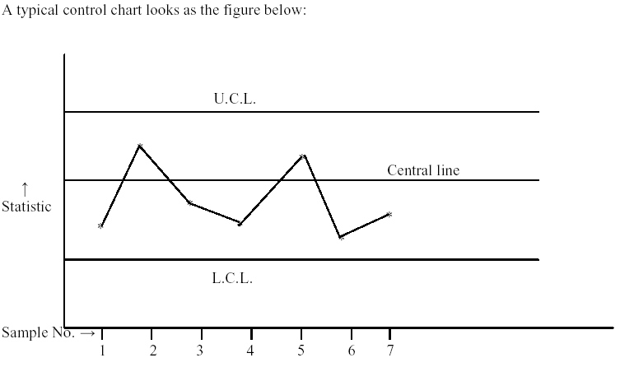Control charts for variables: If the quality characteristic is a continuous variable like
length, weight etc, we use:
(i) the control chart for mean ( x -chart)
(ii) the control chart for standard deviation (s-chart) or
(iii) the control chart for range (R-chart)
If the quality characteristic is a discrete variable like the number of defects in a product,
we use:
(iv) the control chart for number of defects (C-chart)
- Control charts for attributes:
If the product is classified as good (non-defective) and defective, we use
(i) the control chart for fraction defective (p-chart) or
(ii) the control chart for percent defective (100p-chart) or
(iii) the control chart for number of defectives (np-chart)
Each control chart may be of two types:
- (1) Control charts for given standards: When the standard values of the production parameters like mean, standard deviation etc are given, the purpose of the control chart is maintain the production at the desired standard level.
(2) Control charts for no given standards: When the standard values of the production parameters are not given, the purpose of the control chart is maintain the production at a uniform level free from assignable causes. The process itself is used to estimate the parameters for the chart control lines.
- Size of the sample:
For selecting samples from different subgroups, the general practice is to have small samples at short intervals. For ( x , R) or ( x , s) control charts, samples of size 4 to 8 are sufficiently good. The successive samples are generally taken of equal size. For attributes control charts, however, the samples of large sizes are preferred as the diagnostic power of attributes charts is lesser than that of variables charts; also it is easy
to examine products by “go” and “not go” gauges.

